BIJWOORDEN VAN TIJD

Bijwoorden van tijd zijn woorden die aangeven hoe vaak iets gebeurt of voorkomt:
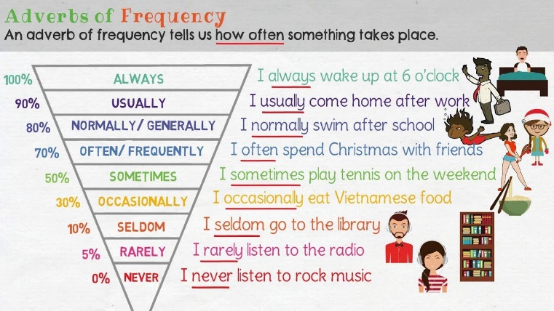
- Always altijd
- Usually gewoonlijk
- Frequently regelmatig
- Often vaak
- Sometimes soms
- Occasionally af en toe
- Seldom zelden
- Rarely zelden
- Hardly ever vrijwel nooit
- Never nooit

Stap 1: Staat er AM / ARE / IS of WAS / WERE
in de zin?

Stap 2 JA  NA/Achter AM / ARE / IS  WAS/ WERE  I am always late. | Stap 3 NEE  EErst het werkwoord  I always speak the truth.

Oefening 1: Wat is juist?
- He goes sometimes to a disco.
He sometimes goes to a disco
- They are never on time.
They never are on time.
- My classmate is usually bored with school.
My classmate usually is bored with school.
- You listen never to my explanation.
You never listen to my explanation.
- He tried often to stop with smoking.
He often tried to stop with smoking.

Stap 1: Staat er AM / ARE / IS of WAS / WERE in de zin?

Stap 2 JA  NA/Achter AM / ARE / IS  WAS/ WERE | Stap 3 NEE  EErst het werkwoord
- We are always tired.
We always are tired.
- Willem comes usually at 8.
Willem usually comes at 8.
- Eline and Vera cook hardly ever dinner.
Eline and Vera hardly ever cook dinner.
- I am always right.
I am right always.
- It rains often in Scotland.
It often rains in Scotland.

Oefening 2:
- Nicole _______________ _______________ here at weekends. (always – comes)
- You _______________ _______________ guest of this restaurant. (regularly – are)
- I __ _____________ _______________ London. (often – visit)
- Pete _______________ _______________ ill. (often – gets)
- These cars _______________ _______________ in the garage. (sometimes – are)
- Fenne _______________ _______________ him. (hardly ever – sees)
- We _______________ _______________ at school. (seldom – are)
- Jorden and Demirhan _______________ _______________ the teacher. (occasionally – help out)
- My cat Tobias _______________ _______________ a gently giant. (always – is)
- Jay _______________ _________ ______ nervous about his test. (probably – is)

Oefening 3:
- Tijn puts tomato sauce on everything. He puts it on ice cream. (usually – probably)
_____________________________________________________________________

- I get to the station on time and the train is late. (always – always)
_____________________________________________________________________

- Janne plays tennis but she plays in the evenings. (often – seldom)
_____________________________________________________________________

- My mother snores so my dad wears ear plugs. (usually – frequently)
_____________________________________________________________________

- My friends are into sports but they are in for a game when I ask them. (never – always)
_____________________________________________________________________
ANTWOORDEN

Oefening 1: Wat is juist?
- He sometimes goes to a disco
- They are never on time.
- My classmate is usually bored with school.
- You never listen to my explanation.
- He often tried to stop with smoking.
- We are always tired.
- Willem usually comes at 8.
- Eline and Vera hardly ever cook dinner.
- I am always right.
- It often rains in Scotland.

Oefening 2:
- Nicole always comes here at weekends.
- You are a regularly guest of this restaurant.
- I often visit London.
- Pete often gets ill.
- These cars are sometimes in the garage.
- Fenne hardly ever sees him.
- We are seldom at school.
- Jorden and Demirhan occasionally help out the teacher.
- My cat Tobias is always a gently giant.
- Jay is probably nervous about his test.

Oefening 3:
- Tijn usually puts tomato sauce on everything. He probably puts it on ice cream.
- I always get to the station on time and the train is always late.
- Janne often plays tennis but she seldom plays in the evenings.
- My mother usually snores so my dad frequently wears ear plugs.
- My friends are never into sports but they are always in for a game when I ask them.

